**Circular Manifesto and Appendix**

**KPN B.V. & [Supplier]**

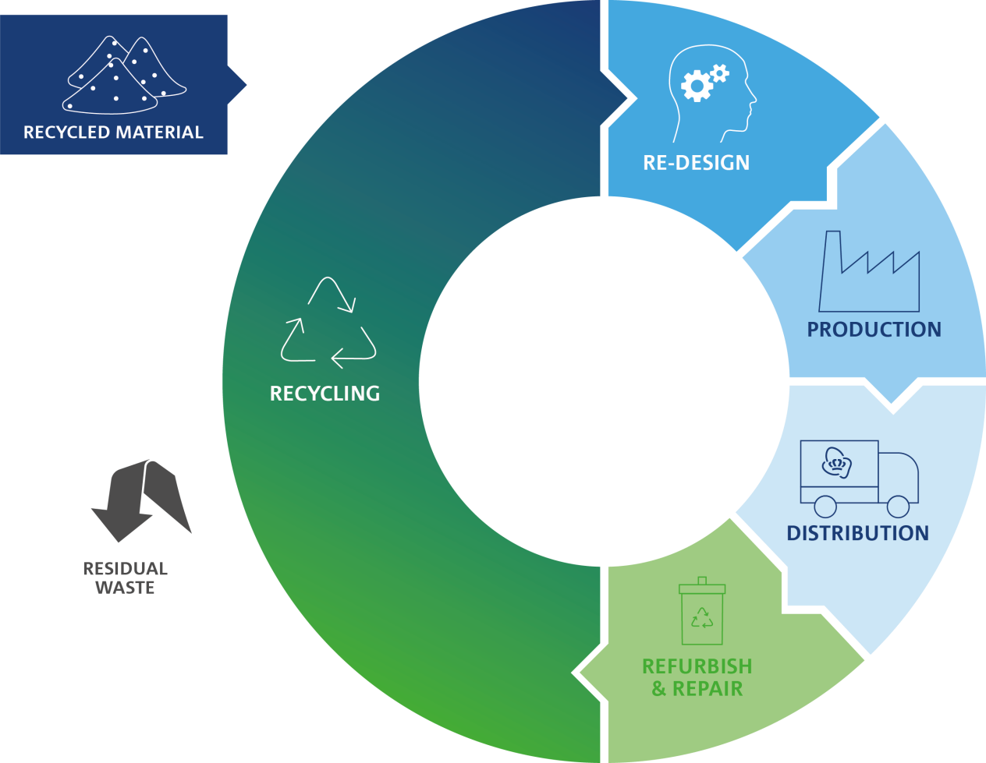

**Circular Manifesto**

1. ***Goals and Ambitions***
   1. For KPN’s own business operations KPN wants to minimize the impact on our planet and its natural resources, in an endeavor not to deplete them further and to remain within the constraints of what the planet itself can generate or restore.
   2. KPN aims to reduce the material impact of KPN products and services by 2025. Therefore all the new equipment used in KPN networks and installed in the data centers and all devices and products built for KPN, should be close to 100% circular by 2025. Meaning that almost all of the materials used should be reusable or recyclable. With this program KPN also support the governments’ ambition to reduce material use by 50%. To achieve circularity, KPN will use fewer materials in KPN’s equipment, increase the life-time of KPN products and wherever possible switch to more sustainable materials.
   3. This manifest is setup together with [Supplier] to support KPN’s Circular goal of close to 100% circular products. This manifest expresses the commitments of KPN and [Supplier] to explore the value and expected impact on the environment of specific projects and initiatives (See Appendix) in support of KPN’s circular business model by using less virgin raw material, extend product lifetime, reuse and recycle all products and improve energy efficiency as much as possible.
   4. With this manifesto KPN and [Supplier] agree to jointly collaborate in contributing to a more circular economy.
2. ***How to change towards a circular business model***For KPN to realize the ambition of becoming close to 100% circular KPN and [Supplier] jointly agree to, when economically viable, develop circular projects and encourage innovation of circular design within four focus areas:
   1. Reduce the use of virgin raw materials
      1. Virtualization; further virtualization and automation of our network to reduce our environmental footprint.
      2. Migrate to software- and service-based models rather than hardware-models
      3. Dematerialization; i.e. dematerialization of DVDs, CDs and newspapers enabled by KPN connectivity by replacing with digital media.
      4. Recycled/Bio based materials; extend the use of recycled/bio based materials where possible.
   2. Extend: Use products longer and more efficient
      1. Lifespan extension; extend the use of products by redesigning products and extend period of maintenance and support.
      2. Increase or optimize rates of utilization.
   3. Cycle: High end second life products and materials by
      1. Use of products/materials that have been designed to be recycled (i.e. with a life cycle perspective in mind).
      2. Reuse; optimal usage of returned products and equipment to be reused by KPN and/or customers or suppliers.
      3. Repair and refurbishment of returned products and equipment to be reused by KPN.
      4. Recycling; improve high value recycling of products, equipment and materials to be reused.
      5. Landfill (reduction); eliminate landfill.
   4. Energy Efficiency
      1. KPN will investigate – together with suppliers – ways to further enhance the energy efficiency of network infrastructure and end-user equipment.
3. ***Together KPN and [Supplier] will develop initiatives for a circular business model including implementation, planning and performance.***
   1. Draw up a list of projects or initiatives to help KPN achieve KPN’s 2025 Circular goals (art.1) and setting joint goals on current initiatives. Start Joint studies to investigate new business models that contribute to a more circular economy
   2. Start joint studies to investigate new business models that contribute to a more circular economy
   3. Plan quarterly meetings to monitor progress on the circular projects or initiatives outlined in the Annex.
   4. Setup and monitor KPI’s on the joint Circular projects and initiatives.

**APPENDIX Circular Manifesto KPN & [Supplier]**

**Specific Projects and initiatives**

To create a more circular business model KPN and [Supplier] agree to work collaboratively on several projects and initiatives. KPN and [Supplier] are committed to explore the value and expected impact on the environment of these projects and initiatives and depending on the outcome pursue them or define new ones.

1. **Governance**

KPN and [Supplier] will monitor the progress of the Circular initiatives on a quarterly basis. The progress will be reported and discussed in supplier meetings. The contract manager of KPN will initiate these meetings and invite the involved business owners. Preparation of the status of the initiatives will be done jointly by the project managers of KPN and [Supplier] assigned to the initiatives.

1. **KPN and [Supplier] jointly agree to focus on specific project and initiatives**
   1. Reduce the use of virgin raw materials
      1. …
   2. Extend: Use products longer and more efficient
      1. …
   3. Cycle: High end second life products and materials by
      1. …
   4. Energy Efficiency
      1. …

On behalf of KPN B.V. On behalf of [Supplier]

[MR./MRS.NAME] [MR./MRS. NAME]

[POSITION] [POSITION]

Place, date ---------------------------------- Place, date ----------------------------------

Signature ----------------------------------- Signature -------------------------------------

On behalf of KPN B.V. On behalf of [Supplier]

[MR./MRS.NAME] [MR./MRS.NAME]

[POSITION] [POSITION]

Place, date ---------------------------------- Place, date ----------------------------------

Signature------------------------------------ Signature------------------------------------